Australian Government
Workforce Australia

Workforce Australia supervisor app

How to use the supervisor app

# Contents

**About the supervisor app** 3

Download the supervisor app 3

Operating systems that support the app 3

Help guides and videos 3

**Set up and sign in to your supervisor app account** 4

Create your account 4

Sign in to the app 6

If you’re using a shared or company device 9

Sign out of the app 10

**Activities and attendance 11**

See your activities 11

See participants in an activity 13

Report attendance for a participant 13

Attendance codes (QR codes) for participants to self-register 19

**See and update your account details 21**

Update your contact information 21

Update your account display name 23

Definitions for fields displayed in your eSAM account 23

Find your Supervisor ID 26

Request to disable your account 26

**When you’re the supervisor and the activity provider 26**

**Technical support 26**

Updates to the app 27

How to find the app and OS version 27

If you need help 29

**Privacy notice and terms and conditions 35**

# About the supervisor app

The supervisor app is for activity supervisors to report participants’ attendance on the day of their activity.

## Download the supervisor app

You can download the free app from your app store:

* [Apple App Store](https://apps.apple.com/au/app/supervisor-wfd/id938537253)
* [Google Play](https://play.google.com/store/apps/details?id=au.gov.employment.supervisor)

## Operating systems that support the app

The app is available for:

* Apple devices with iOS 15 and above
* Android devices with 6.0 and above.

## Help guides and videos

This guide and videos to help you use the app are available under the supervisor app’s **More** menu.

More menu on the public version of the supervisor app
 OR 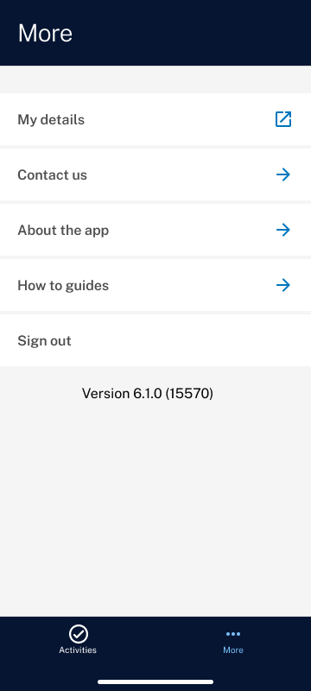

Figure 1: More menu – public version of app Figure 2: More menu – signed in to app

At the **More** menu, you can select **How to guides** and then:

* **Supervisor app guide** to access this guide
* **Logging into the app video** for help logging in
* **Navigating the app video** for help using the app.

# Set up and sign in to your supervisor app account

## Create your account

To use the app, you need to create a Workforce Australia supervisor account and link it to your [**myGovID**](https://www.mygovid.gov.au/).

Supervisor accounts are created in the Employment Security Access Management (eSAM) application. We use myGovID to identify people and we use eSAM to authorise access to the app.

### Step 1. Set up your myGovID if you don’t have one

1. If you don’t have a myGovID, you’ll need to set one up.
2. Make sure your myGovID:
   * has an identity strength of **Standard** or higher
   * is set up on your personal device, not a company or shared device.

### Step 2. Use the link sent to your email to complete the process

1. An activity provider will invite you to create a supervisor account with Workforce Australia. You'll get an email with a unique link. The link will be valid for 30 days. After this time, the link will expire and you’ll need to contact the activity provider and ask them to send you a new email invite.
2. Sign in with myGovID via this unique link. You need to use this link to see the User Security Declaration (steps 3 to 5) and access the app.

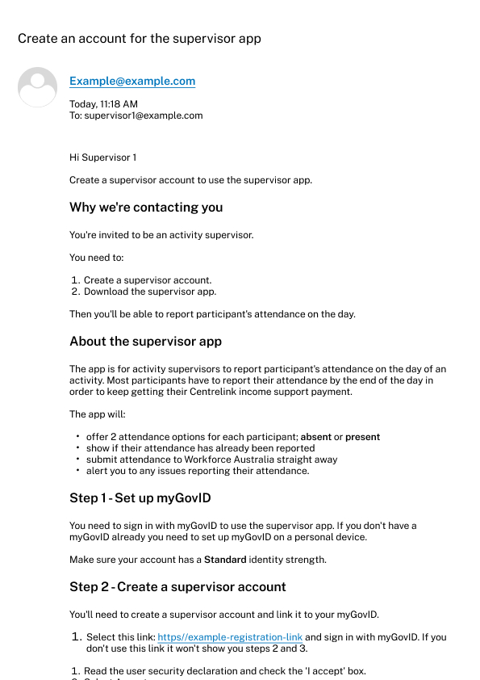

Figure 3: new user registration email

1. Read the **User Security Declaration**.
2. Check the **I accept** box.
3. Select **Accept**.

**Note**: You must accept the User Security Declaration to access the app.

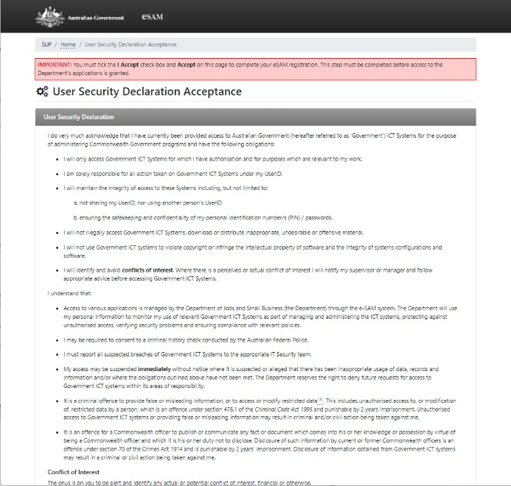 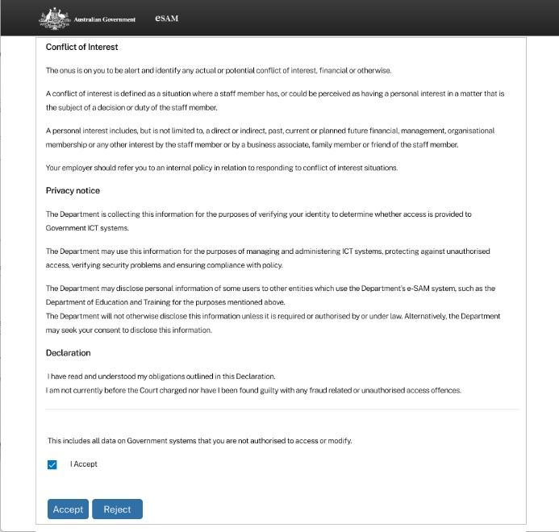

Figure 4 and Figure 5: User Security Declaration acceptance

1. You’ll see a self-registration success page. This means you’re registered in eSAM.
2. Your myGovID email address will be saved to your supervisor app account by default and will be searchable by providers in Workforce Australia Online for Providers and the Employment Services System Web (ESS WEB).
3. To change the email address stored in eSAM to your preferred email address, click on the link in the success page. For help, go to **Update your email address**.
4. If you update the email address, make sure you tell your activity provider. They need to know which email address to use to search for your supervisor account in Workforce Australia Online for Providers or ESS Web. **Note**: You’ll still use your myGovID email address to sign in to the app.

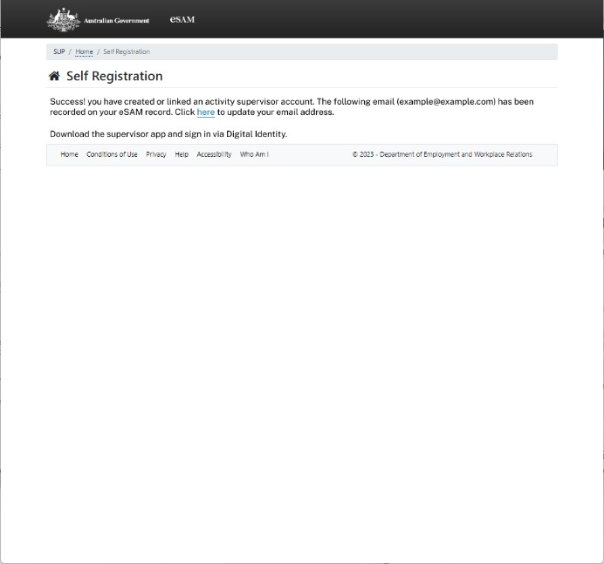

Figure 6: self-registration success page

## Sign in to the app

After you’ve downloaded the supervisor app:

1. Open the app.
2. Select **Sign in or register with myGovID**.

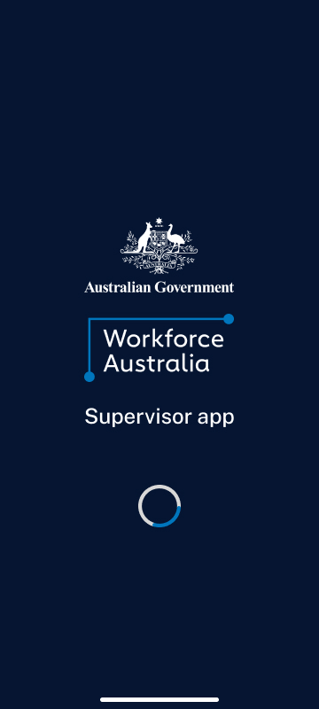 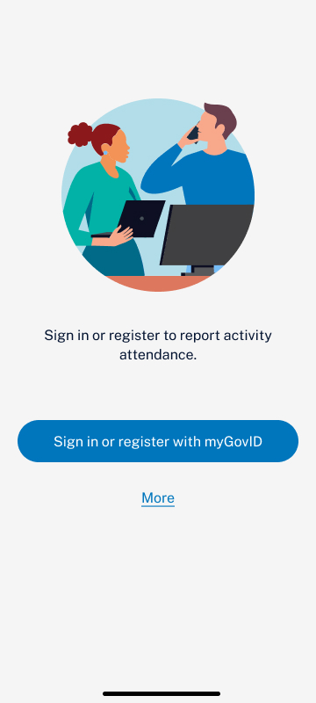

Figure 7: app splash screen Figure 8: app sign in page

1. Select **myGovID**.

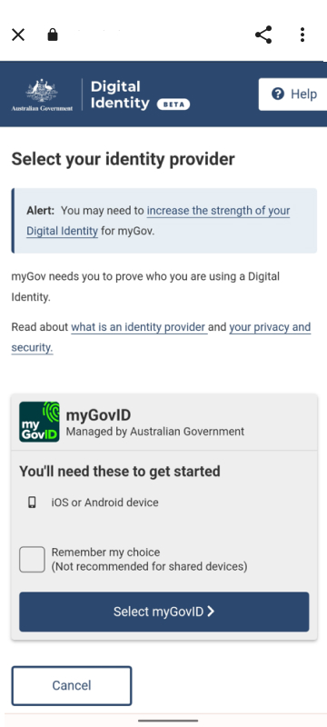

Figure 9: myGovID sign in

1. Enter your myGovID email address and select **Login**.

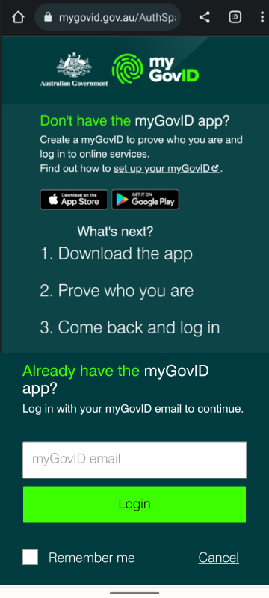 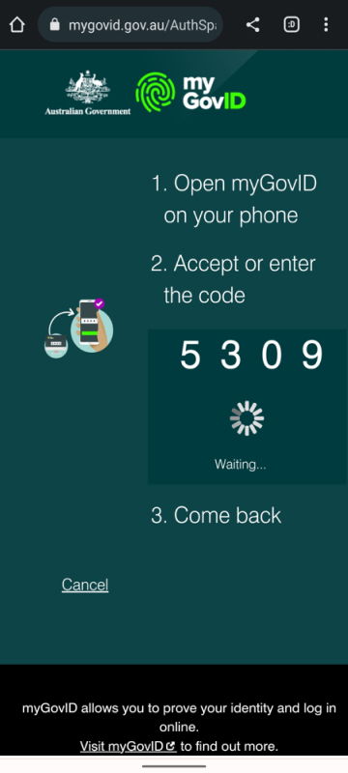

Figure 10: myGovID email login, Figure 11: myGovID authentication code

1. Open the myGovID app from your personal device.

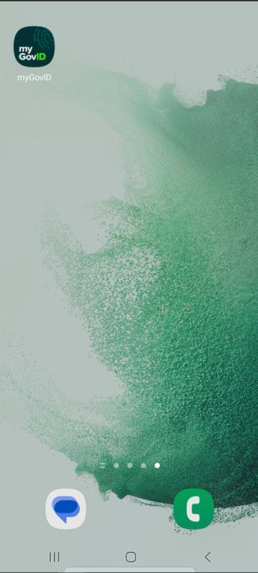

Figure 12: myGovID app icon

At the **Login request** screen:

1. Enter the code from the myGovID web page to your myGovID app.
2. Select **Accept**.

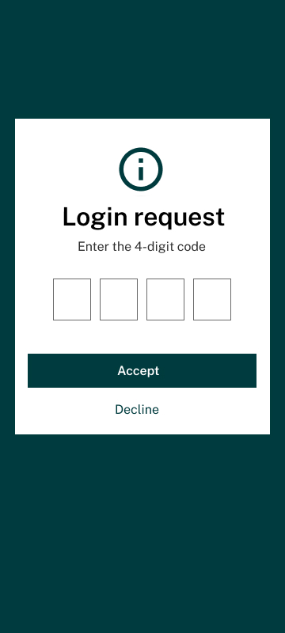 MyGovID app login request code completed


Figure 13: myGovID app login request code, Figure 14: myGovID app login request code completed

1. Go back to the myGovID web page.
2. The page may reload with a **Digital Identity consent form** if you haven’t previously checked the box for **Yes, and don’t ask me again.**
3. Select **Consent**.

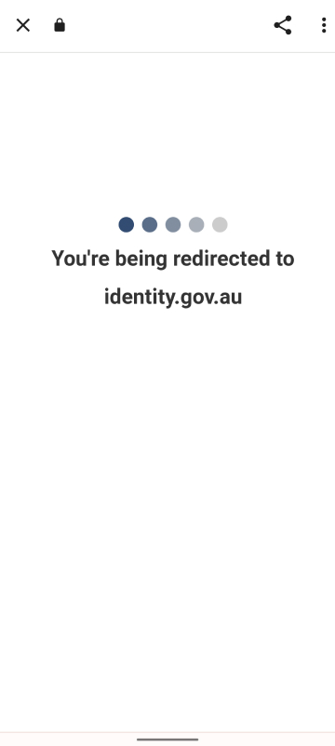 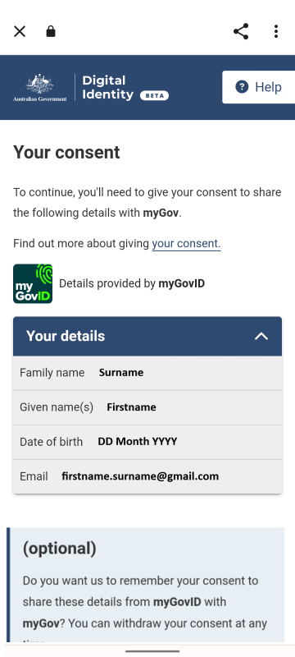 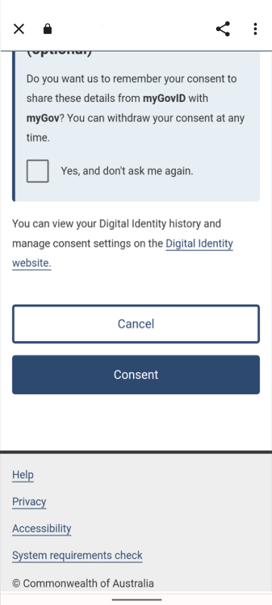

Figure 15: Digital Identity loading page, Figure 16 and Figure 17: Digital Identity consent form

1. Read the Terms and conditions. You’ll see them the first time you sign in and, again if they’re updated.
2. Select **I agree.**

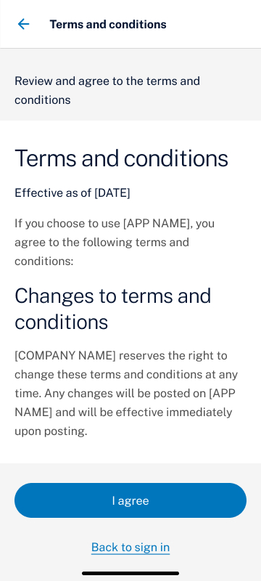

Figure 18: app conditions of use screen

## If you’re using a shared or company device

If you’re using a shared or company Android device, you may need to clear the app cache before trying to sign in with a different account. For help, go to Technical support.

Note: The supervisor app can be installed on a company device. However, the myGovID app should be installed on your personal device as it’s linked to your personal identity.

## Sign out of the app

To sign out of the supervisor app:

1. Select **More**.
2. Select **Sign out**.
3. You’ll be taken back to the sign in page.

 

Figure 19: app More menu – signed in, Figure 20: app sign in screen

# Activities and attendance

## See your activities

1. Sign in to the supervisor app via myGovID.
2. **Your activities** will show the list of your linked activities scheduled in the next 7 days.

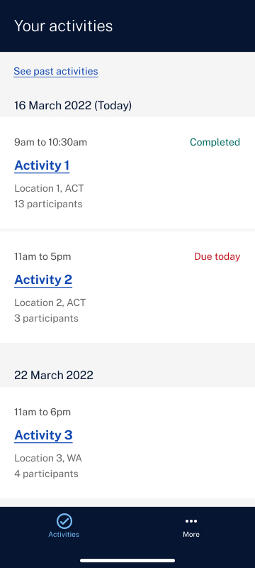

Figure 21: Your activities page

1. If you don’t have any activities scheduled in the next 7 days, you’ll see a message saying you don’t have any activities.
2. If you want to see the list of past activities, select **See past activities**. This will show you the past activities scheduled in the last 7 days.

 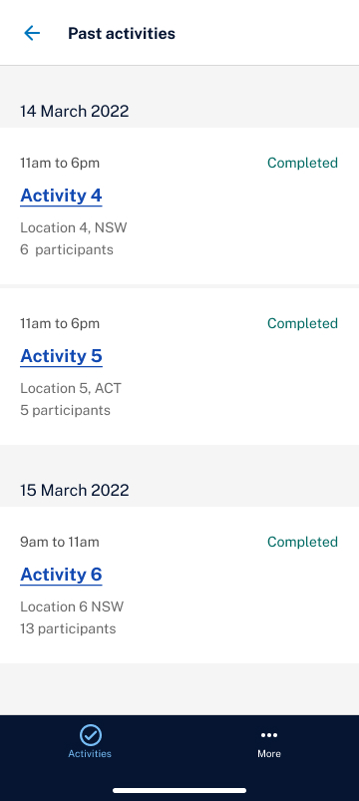

Figure 22: Your activities page, Figure 23: Past activities page

1. To see the details of an activity, select the activity from **Your activities** list.
2. Select **View activity details.**

Supervisor App - your activities page example
 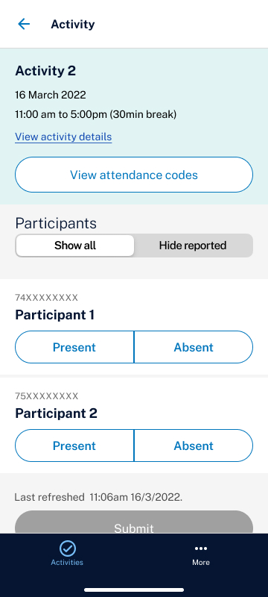 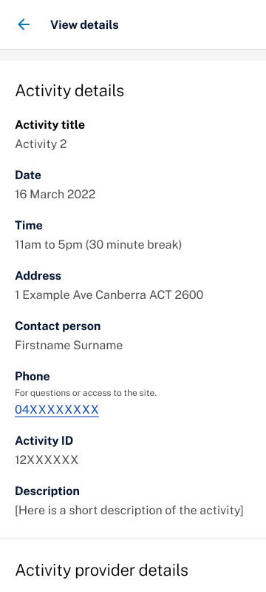

Figure 24: Your activities page, Figure 25: Activity participant’s page, Figure 26: View activity details page

## See participants in an activity

To see the participant list for an activity:

1. Sign in to the supervisor app via myGovID.
2. Select the activity from **Your activities** list.
3. You’ll see the participant list.
4. By default, the participant list will display all individuals, including any who have already had their attendance reported. To hide participants who have already reported, click on the toggle labelled **Hide reported**.

 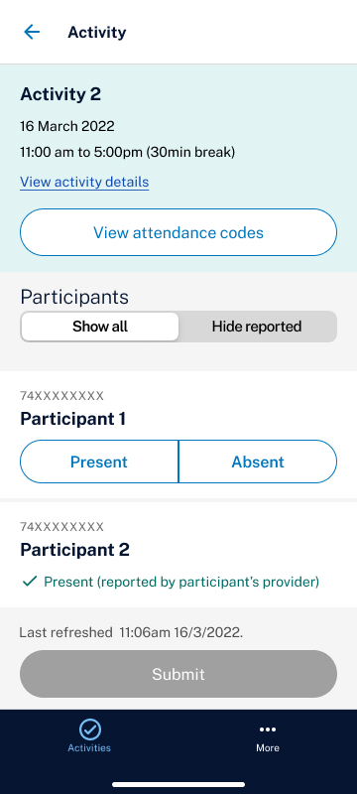 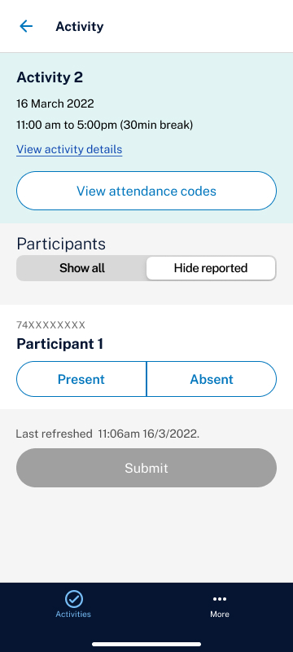

Figure 27: Your activities page, Figure 28: Activity participant’s page – show all, Figure 29: Activity participant’s page – hide reported

## Report attendance for a participant

You can only report attendance on the day of the activity.

1. Sign in to the supervisor app via myGovID.
2. Select the activity from the list in **Your activities**.
3. Select either **Present** or **Absent** for each participant.
4. If no attendance has been selected, you won’t be able to select **Submit**.

 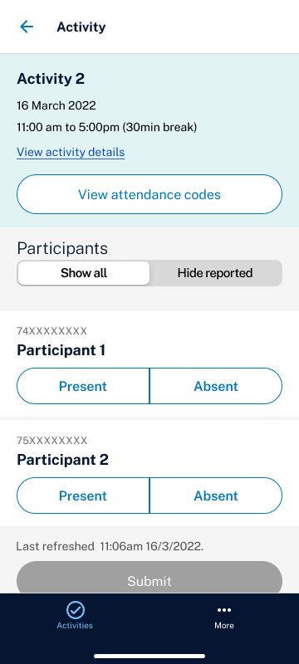 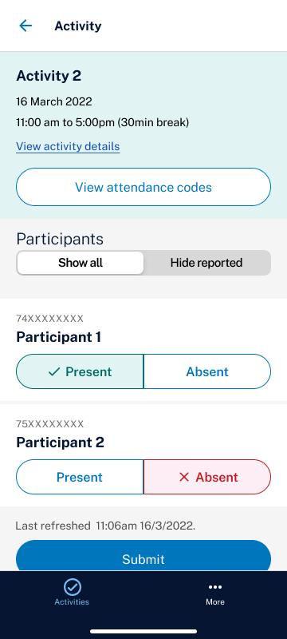

Figure 30: Your activities page, Figure 31: Activity participant’s page, Figure 32: Activity participant’s page – attendance selected

1. When you report a participant as absent, you’ll be asked to confirm it. Check the absent participant’s details are correct and select **Submit**.

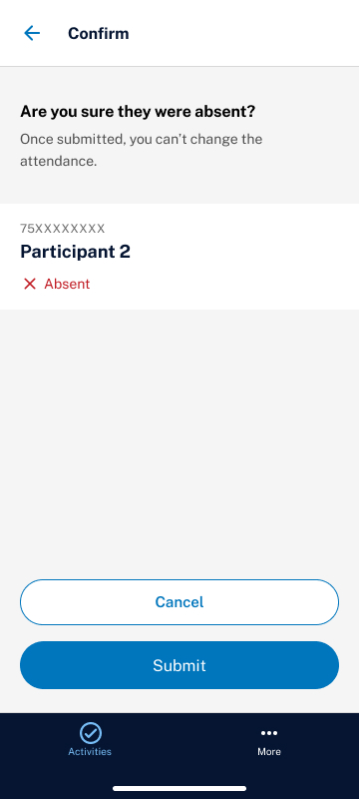

Figure 33: attendance confirmation page

1. You can submit the attendance of each participant individually, in groups, or all at the same time. It will be reported to Workforce Australia Online for Providers straight away.
2. You’ll get a confirmation message and the participant list will update.

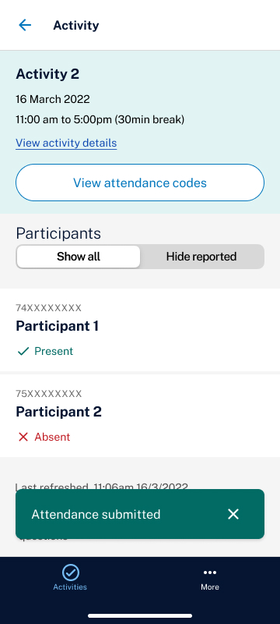

Figure 34: attendance submitted confirmation message

### What the attendance results mean

**Attendance not reported:** No result was reported in the app on the day of the activity for that participant.

**Attendance not required:** The participant’s requirement to attend the activity on that day has either been rescheduled or is no longer required.

**Exited from activity:** The participant has been exited from the activity and will no longer be listed as a participant for current or future dates.

**Present:** The participant has been marked as present for that activity on that day.

**Absent:** The participant has been marked as absent for that activity on that day.

**Valid absence:** The participant has been marked as absent for that activity for that day but with a valid reason.

### Error messages

If you get an error message that can’t be resolved, contact the activity provider for help.

Error messages happen when:

1. A participant’s attendance has already been reported when you submit. You’ll see who reported the attendance and the result for each participant.

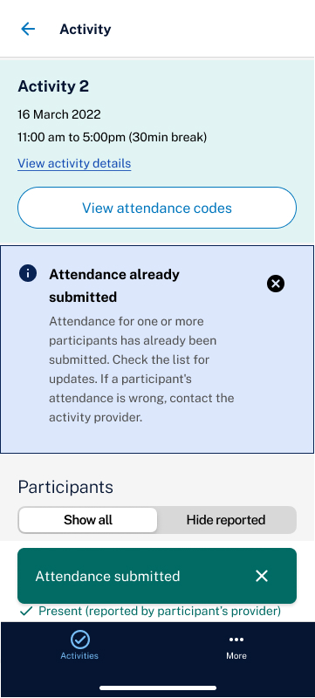 attendance already submitted error


Figure 35: attendance already submitted message, Figure 36: attendance already submitted error

1. A participant's attendance couldn't submit for any reason. In this instance, check the list and submit again, or contact the activity provider.

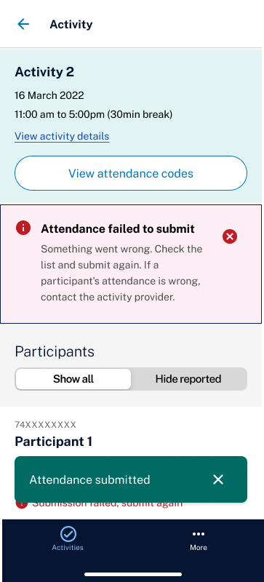 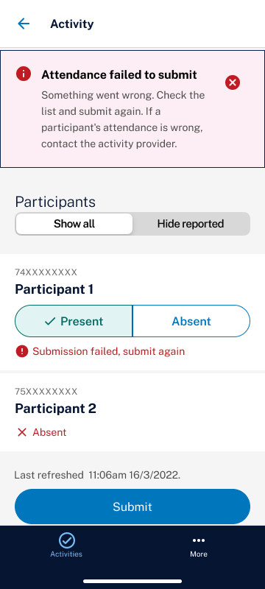

Figure 37: attendance failed to submit message, Figure 38: attendance failed to submit error

1. You try to report attendance before the day of the activity. You can only report attendance on the day of the activity.

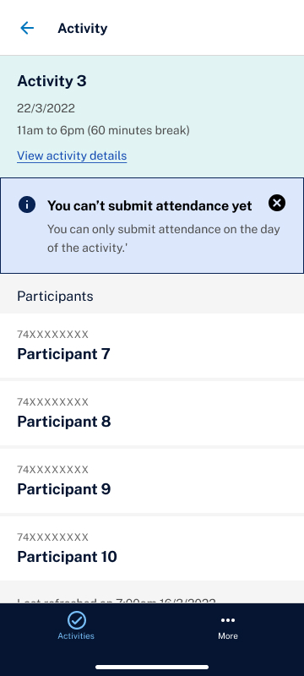

Figure 39: future attendance submission message

1. You try to report attendance for a past activity.

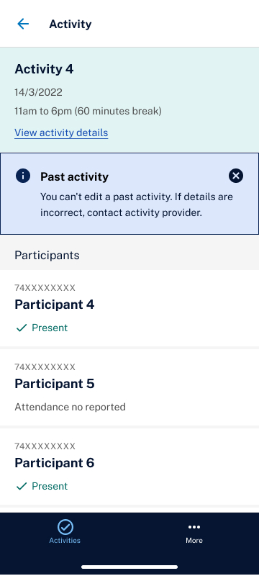

Figure 40: past attendance submission message

### When someone else has reported a participant’s attendance

Attendance reported by another party (in Workforce Australia Online for Providers or ESS Web) will display in the app straight away as long as the app is online and the participant list has been refreshed.

Different user types displayed in the app are:

* **Provider**: The participant’s case managing provider.
* **Supervisor**: The Supervisor currently signed in to the supervisor app.
* **Another supervisor**: A supervisor different to one currently signed in to the app.
* **Departmental user**: A Digital Services Contact Centre (DSCC) or departmental staff member.
* **Individual**: A participant who has self-reported using the QR or passcode.
* **Services Australia**: A Services Australia staff member.

### When a participant is missing from the list

There can be many reasons why an expected participant is missing from the participant list. Contact your activity provider if you think the list is incorrect for any of the following reasons:

* A participant may not have a systems-based referral to the activity.
* Your supervisor account may not have been correctly linked to the activity location.
* The activity may not have been set up correctly with the correct start and end dates.
* A participant may have been incorrectly marked as exited or exiting from the activity.
* A participant’s requirement to attend the activity has been updated to be no longer required.

## Attendance codes (QR codes) for participants to self-register

Most participants have an obligation to report their attendance at an activity. They do this by scanning a QR code or entering a passcode to their Workforce Australia Online for Individuals account.

The codes for the activity are saved in the supervisor app. Participants can scan the QR codes from your device or enter the passcode in their own device.

These codes will also be emailed to you before the activity starts.

### Find attendance codes

1. Open the supervisor app.
2. Select the activity.
3. Select **View attendance codes.**
4. The QR code and passcode will be shown.

  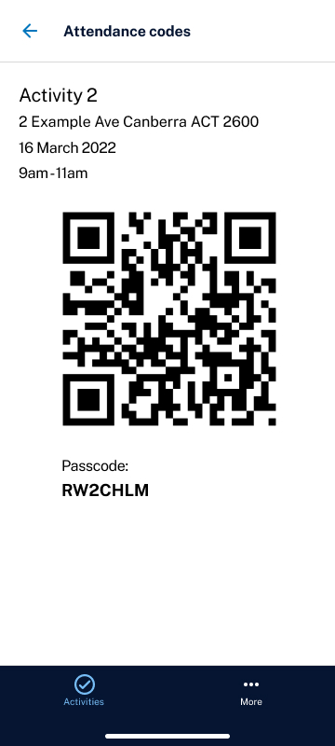

Figure 41: Your activities page, Figure 42: Activity participant’s page, Figure 43: Activity attendance codes page

1. If the activity is longer than 4 hours there will be a **session 1** code and a **session 2** code. To see the session 2 code, select the **Session 2** toggle on the right-hand side of the screen.

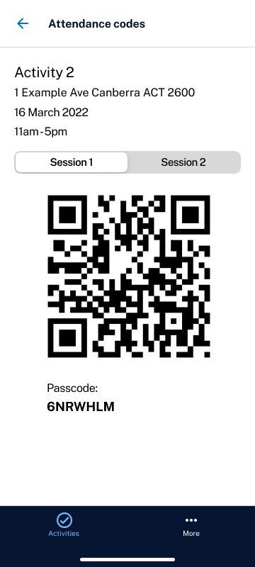

Figure 44: Activity attendance codes page – multiple sessions

# See and update your account details

Supervisor accounts are updated in [eSAM](https://ecsn.gov.au/ESAM/), the system we use to authorise access to the supervisor app. When you’re signed in to eSAM, you can review or update certain account details, such as your contact information and display name.

## Update your email address

1. While signed into the app, select **More** at the bottom of the screen.
2. Select **My details.**

 

Figure 45: Your activities page, Figure 46: app More menu – signed in

1. The eSAM sign in page will load.
2. Scroll down to the option titled **Digital Identity (myGovID) for** **Individuals.**
3. Select **Continue with Digital Identity.**

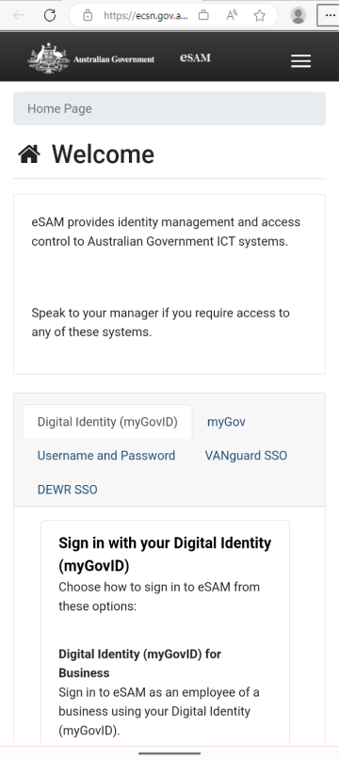 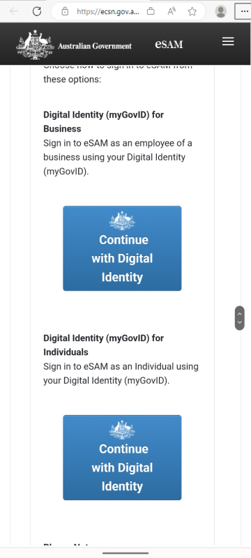

Figure 47 & Figure 48: eSAM login page

1. Follow the prompts to sign in with your myGovID.
2. Once successful, you’ll see the eSAM homepage.
3. Select **My Details.**
4. From the **My Details** page, update the **Email Address** if you want to change it, and select **Submit**.

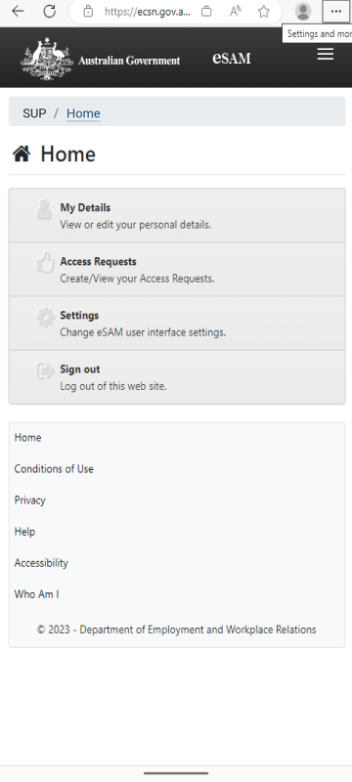 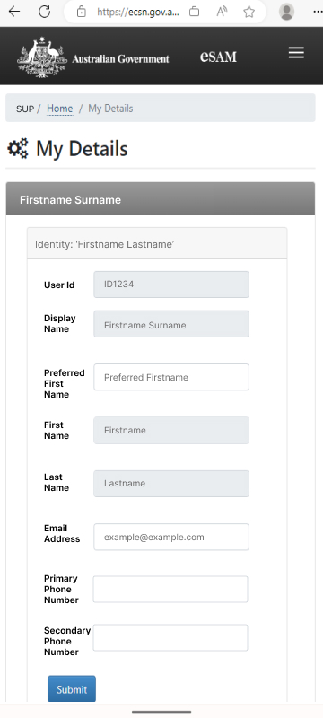

Figure 49: eSAM home page, Figure 50: eSAM My details page

1. Your email address has now been updated in the supervisor app. Once your email address has been changed, you will still use your myGovID email address to sign in to the app.

## Update your account display name

Some fields in your eSAM account will be visible to providers in either Workforce Australia Online for Providers or ESS Web, such as your:

* **Display Name**
* **Preferred Name**
* **Email Address**.

The display name can only be updated via [myGovID](https://www.mygovid.gov.au/help-managing-your-mygovid#how-to-update-your-details-in-the-mygovid-app). Once successfully updated in myGovID, the display name field will update in eSAM when you next sign in.

## Definitions for fields displayed in your eSAM account

None of your eSAM account details are displayed in the supervisor app except your Supervisor ID. See the descriptions below for each field, where they are displayed and how you can update the details.

### Identity

#### User ID

* The eSAM **User ID** is a unique system generated identifier for each supervisor and can’t be updated.
* You don’t need to use this ID in the supervisor app.

#### Display Name

* This is the full name as shown on your myGovID.
* If your name is updated on your myGovID, the **Display Name** in eSAM will be updated at your next sign in to eSAM via myGovID.

#### Preferred First Name

* You can add or update your **Preferred First Name** in eSAM.
* Update this field if you want to use a preferred name to display in ESS Web or Workforce Australia Online for Providers instead of your formal name from Digital Identity (myGovID).
* The **Preferred First Name** is not synchronised with the name from myGovID, so it remains the same unless you update it.
* If a **Preferred First Name** is added, the **Display Name** will also be updated to reflect the preferred name entered (i.e. Preferred First Name and Last Name).
* If a **Preferred First Name** is entered in eSAM, the Preferred First Name will be displayed in ESS Web or Workforce Australia Online for Providers in place of the **First Name**.

#### First Name

* The **First Name** is synchronised with the first name from myGovID and is displayed in ESS Web or Workforce Australia Online for Providers, unless a **Preferred First Name** is entered.
* If the **First Name** is changed in myGovID, the **First Name** in eSAM will be changed at next sign in to eSAM via myGovID.
* If a **First** **Name** is not entered in myGovID, this field will be blank and can be edited.

#### Last Name

* The **Last Name** is synchronised with the last name from myGovID and is displayed in ESS Web or Workforce Australia Online for Providers.
* If the **Last Name** is changed in myGovID, the **Last Name** in eSAM will be changed at next sign in to the app or eSAM via myGovID.
* You can’t update the **Last Name** directly in eSAM.

#### Email Address

The **Email Address** field can only be updated by you. It’s initially populated from the email listed in your myGovID during the eSAM registration. This email address is displayed in ESS Web or Workforce Australia Online for Providers. If updated, you’ll see the changes in ESS Web and Workforce Australia Online for Providers, but it will not update the email address listed in your myGovID.

#### Primary and Secondary Phone Number

The **Primary and Secondary Phone Number** fields can only be updated by you. They’re left blank unless you add a phone number. If a phone number is added, it will be displayed in ESS Web or Workforce Australia Online for Providers.

### Current application ‘SUP’

#### Account Username (Supervisor ID)

The **Account Username** is generated by eSAM and is used to identify the user in the app. This will be your Supervisor ID. It’s useful to provide to the technical support team if you have an issue with your account or to activity providers if they need to link you to multiple activity locations. You can’t update it in eSAM.

#### Account Email Address

The **Account Email Address** is not used in the app. By default it will always be blank and you can’t update it in eSAM.

#### Account Status

This displays your current app account status in eSAM, Workforce Australia Online for Providers and ESS Web. You can’t update it in in eSAM. Different statuses include:

* **Enabled:** When you’re actively performing the supervisor role.
* **Disabled:** When you’re no longer performing the role of a supervisor for an activity provider.
* **Inactive:** If you haven’t signed in to the app or eSAM for 40 days and your account status automatically becomes inactive. Your account is enabled automatically when you sign in to the app or eSAM with your myGovID.
* **Suspended**: If the department suspends an account if it’s suspected or alleged the account has been used inappropriately.

#### Group

Displays how your account was created (e.g. self registration). You can’t update it in eSAM.

#### Role

The authorised role applied to your eSAM account to access the app. You can’t update it in eSAM.

 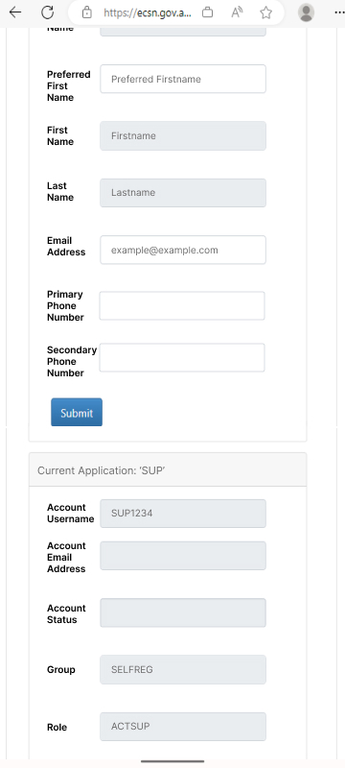

Figure 51: eSAM My details page – Identity information, Figure 52: eSAM My details page – application information

## Find your Supervisor ID

The Supervisor ID is created when you complete the registration process. Find it in the app by navigating to either:

* **More tab** > **About the App** > **Supervisor ID**
* **More tab** > **My details** > **sign in to eSAM** > **Current Application: SUP** > **Account username**.

## Request to disable your account

Departmental accounts (eSAM accounts) can’t be deleted due to legal auditing and data retention requirements.

If your account is no longer required, you can ask the relevant activity provider to lodge a request to have your account status changed to disabled.

Supervisors who work for an activity provider can search for a task card in the provider portal and follow the instructions. If you don’t have access, speak to your activity provider and ask them to log the request on your behalf.

# When you’re the supervisor and the activity provider

If you’re an activity provider as well as a supervisor and you have any of the following issues, you can find relevant task cards to follow in the provider portal. If you’re having trouble finding the right task card for your issue, please contact the support team for help.

**Expected participants are missing from the participant list**: Participants may not have been correctly placed into the activity. Contact their referring provider (if applicable) or direct the participant to contact the DSCC.

**You’re receiving an error ‘*We can’t find your account’:*** Your supervisor account may not have been set up yet.

**You’re missing activities from the activities list**: Your supervisor account may not have been correctly linked to the activity.

**The activity details (including dates) are incorrect:** The activity may not have been set up correctly with the correct start and end dates.

**A participant appears to have the wrong attendance reported**: Contact their referring provider (if applicable) or direct the participant to contact the DSCC to have this updated.

# Technical support

If you’re having technical issues using the app, you can:

**Step 1: Refresh the screen:** Sometimes information is updated after the page loads. Try refreshing the screen by tapping on it with your finger and dragging down before releasing.

**Step 2: Clear the cache:** Sometimes the device stores old data in the app and it needs to be cleared. This often needs to be done if you have multiple supervisors sharing an Android device. Clear the cache before another supervisor signs in to the app.

**Android** devices:

1. Select **settings.**
2. Select **apps.**
3. Select **supervisor app** from the list.
4. Select **storage.**
5. Select **clear cache.**
6. Close and re-open the **supervisor app.**

**iOS** devices:

* + - 1. Close and re-open the **supervisor app**

**Step 3: Uninstall/reinstall the app** – If none of the previous steps work, try reinstalling the app.

**Android** devices:

* + 1. Select and hold down on the **supervisor app** icon.
    2. Select **uninstall.**
    3. Go to the **Play Store** and search for the **supervisor app.**
    4. Select **install**.

**iOS** devices:

1. Select and hold down on the **supervisor app** icon until the icons start to shake.
2. Tap the **minus** symbol on top left of the app.
3. Select **delete app.**
4. Select **delete** to confirm.
5. Go to the **App Store** and search for the **supervisor app.**
6. Select **install**.

**Step 4: Check your device has the minimum supported operating system (OS):**

* **Android** devices: OS 6.0 and above
* **iOS** devices: OS 15 and above

## Updates to the app

We continuously update and improve the app. Download updates when they’re available. You can change your device settings to allow automatic updates.

To read the details of each update, go to your app store and read **what’s new** for the app.

## How to find the app and OS version

1. Select **More** from the sign-in screen. If you’re already signed in, select **More** at the bottom of the screen.

 OR 

Figure 53: app sign in screen, Figure 54: Your activities page

1. Select **About the app**

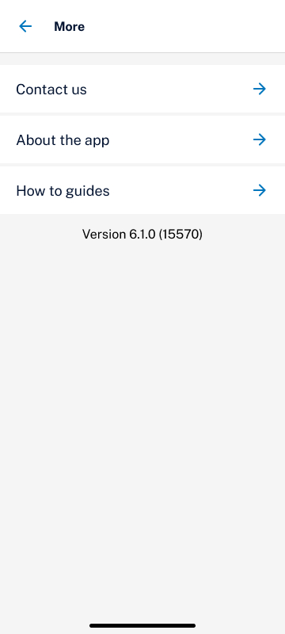 OR 

Figure 55: app More menu – public version, Figure 56: app More menu – signed in

Under the **System Information** heading, the app version will be listed under **App version** and the device operating system (OS) version will be listed under **OS version**.

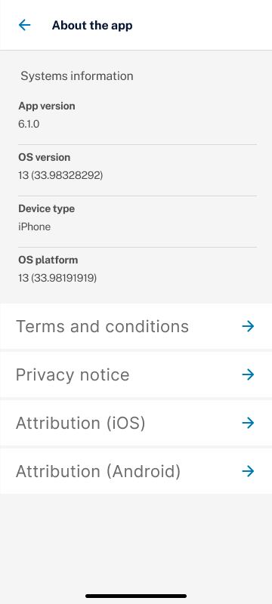 OR 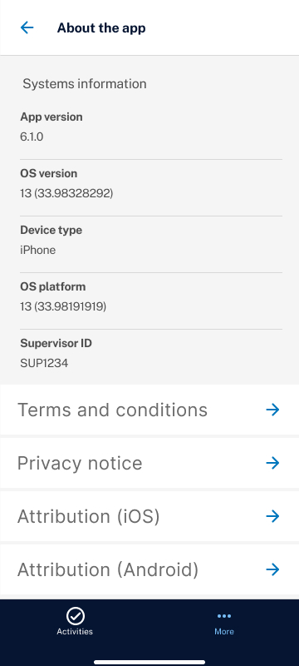

Figure 57: About the app page – public version, Figure 58: About the app page – signed in

If the OS version listed is less than the minimum described in the **Operating systems that support the app** section, you need to update your device OS. The steps to update an OS can be different depending on the device and model so search the internet for guidance.

## If you need help

### Issues signing in to your account

#### myGovID

If you have any problems setting up or accessing your myGovID, or the myGovID app, [contact my GovID for help.](https://www.mygovid.gov.au/help-contact-us#general-support)

#### Account registration problems

Contact your activity provider for help if you have any problems with your supervisor app account, including;

* The registration link has expired.
* Your supervisor app account is disabled.
* You want to request to disable your supervisor account.
* You don’t have any linked activities.

### Contact your activity provider

Your activity provider should be your first point of contact for any of the following issues:

* The participant list in the app is missing or has incorrect participants listed.
* The activity is missing or has incorrect activities listed.
* Participant attendance is incorrect or needs to be updated by a case managing provider.
* You have any other business questions or concerns.

### Activity provider contact details

If you need to contact the activity provider or site contact person:

1. Select the activity from **Your activities** list.
2. Select **View activity details**.
3. The site contact name and details will be listed under the **Activity details** section.
4. The activity provider contact name and details will be listed under the **Activity provider details** section.

 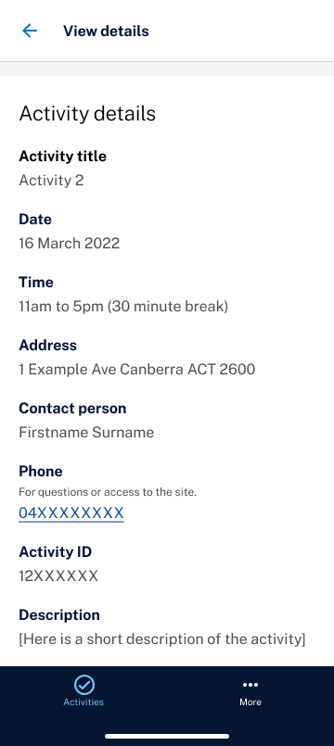 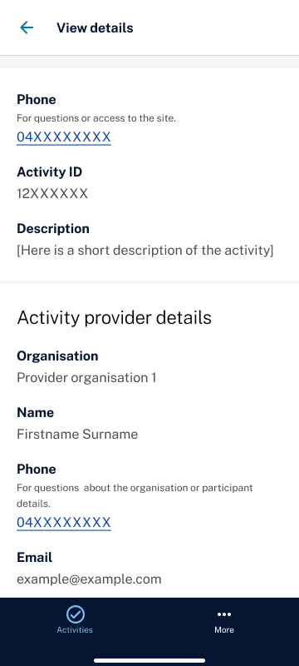

Figure 59: Activity participant’s page, Figure 60 & Figure 61: View activity details screen

### Technical support contact details

If these steps don’t fix the problem, you can contact the support team by:

* calling 1300 305 520
* filling in the contact form in the app.

### Fill out a contact form

1. On the sign in screen select **More**. If you’re already signed in, select **More** at the bottom of the screen.
2. The contact form will look slightly different if you’re not signed in and you won’t be able to upload attachments.

**Supervisor App sign in screen example
** OR 

Figure 62: app sign in screen, Figure 63: Your activities page

1. On the **More** screen, select **Contact us**.

 OR 

Figure 64: app More menu – public version, Figure 65: app More menu – signed in

1. To call the support team, select **call 1800 305 520**.
2. To use the contact form, select **Fill out contact form**.

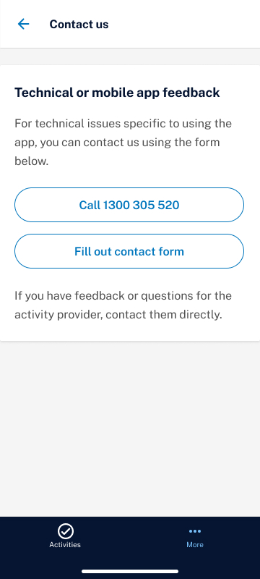

Figure 66: app contact us screen

1. Enter your email address if you’d like a response.
2. If you’re signed in, your Supervisor ID will automatically be included in the submitted contact form. If you don’t want to provide this to support teams, check the box ‘**Don’t provide my Supervisor ID’**. If you’re not signed in, your Supervisor ID won’t be provided.
3. Describe the issue and if signed in, upload images if possible. If your image isn’t in the correct file type, you can convert HEIC file types to JPEG.
4. If you upload an image that exceeds the file size limit, try taking a screenshot of the image on the device and upload the screenshot instead. Screenshots will usually be a much smaller file size.

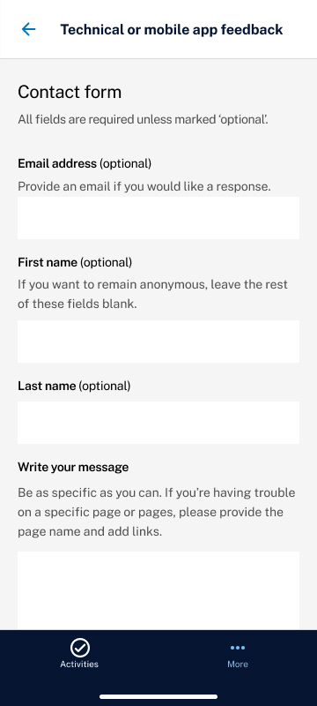 OR 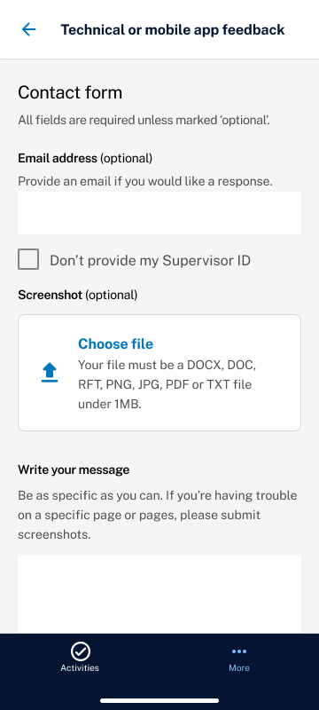

Figure 67: app contact form – public version, Figure 68: app contact form – signed in

1. Select **Submit**.

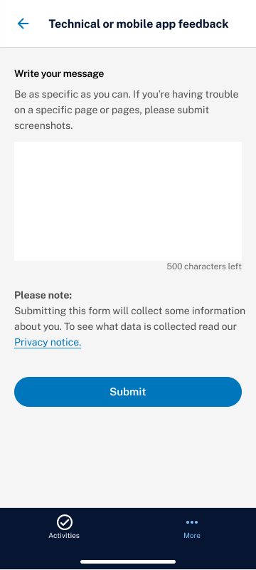

Figure 69: app contact form

1. You’ll get a confirmation message.

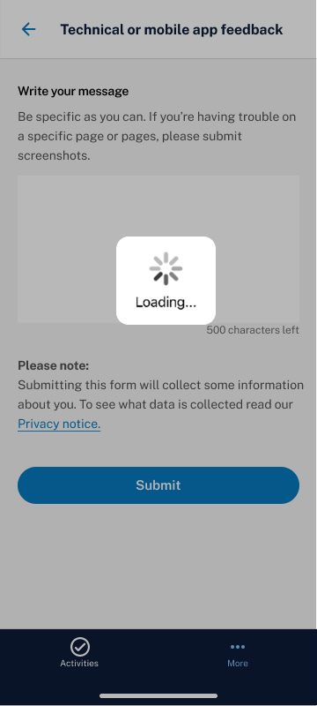 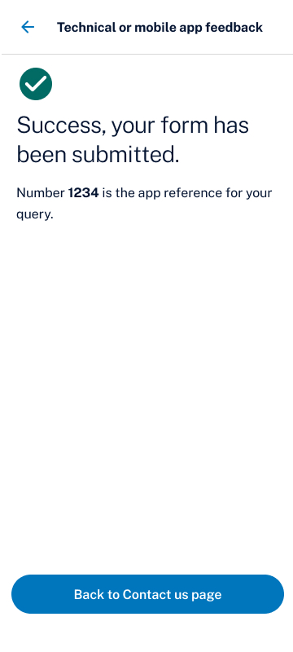

Figure 70: app contact form loading screen, Figure 71: contact form submission message

#### How to convert HEIC file types to JPEG

On some Android devices, the pictures you take with the camera are saved as HEIC files. You can't upload a HEIC file to the app. But you can convert it to a JPEG file and upload that.

For most **Android** devices:

1. Select the image you want to convert.
2. Select the **edit icon**.
3. Select **edit**.
4. Select **save a copy** to save the image as a JPEG photo to a location you choose.

# Privacy notice and terms and conditions

1. Select **More** from the sign-in screen. If you’re already signed in select **More** at the bottom of the screen.

**Supervisor App sign in screen example
** OR 

Figure 72: app sign in screen, Figure 73: Your activities page

1. Select **About the app**

 OR 

Figure 74: app More menu – public version, Figure 75: app More menu – signed in

1. Select **Terms and conditions** to see the terms and conditions.
2. Select **Privacy notice** to see the privacy notice.

 OR 

Figure 76: About the app page – public version, Figure 77: About the app page – signed in